Artificial Intelligence

Enabled Application for Ebola Disease Diagnosis

Tuesday, 7 June 2022

# Overview

## Project Background and Description

|  |  |
| --- | --- |
|  | Describe how this project came about, who is involved, and the purpose.  Note: To delete any tip (such as this), select it and start typing. If you’re not yet ready to add your own text, select a tip and press spacebar to remove it. |

This study is aimed at designing a technique capable of classifying filovirus diseases (EVD and MVD) with reference to Baltimore Classification approach to predict the presence of the virus in a suspected case. And to further Evaluate the accuracy and reliability of the prediction model.

The specific objectives are to:

Design an integrated filovirus disease spread control model that is capable of analyzing and classifying their distinct symptoms to predict the presence of EVD or MVD in Suspected cases.

Integrate Geographical Information System (ArGIS) to improve Contact Tracing and surveillance of the suspected cases.

Evaluate the overall performance (that is the Accuracy, Reliability and Specificity) of the model and communicate data in Real-time to the stakeholders.

## Project Scope

|  |  |
| --- | --- |
|  | Project scope defines the boundaries of a project. Think of the scope as an imaginary box that will enclose all the project elements/activities. It not only defines what you are doing (what goes into the box), but it sets limits for what will not be done as part of the project (what doesn’t fit in the box). Scope answers questions including what will be done, what won’t be done, and what the result will look like. |

The project scope is limited to creating a mobile app application that allow users to register and enter their health information for machine learning analysis of Ebola disease

## High-Level Requirements

|  |  |
| --- | --- |
|  | Describe the high level requirements for the project. For example: |

The Ebola smart health care system would include the following:

* Ability to allow the both the admin and users to access the application by downloading it from Google playstore
* Ability to track user geo-location information at near real-time
* Ability to incorporate analytics dashboard for the admin
* Ability to predict the presence of EVD or MVD in Suspected cases

## Deliverables

|  |  |
| --- | --- |
|  | List agencies, stakeholders or divisions which will be impacted by this project and describe how they will be affected by the project. |

|  |  |
| --- | --- |
| Item | Description |
| ML Model | * Data preprocessing * Feature engineering * Prediction |
| ArGIS | * Geo tracking (location, IP) * Device tracking (Device, OS, Platform) * Real-time monitoring |
| App Development | * Backend development * Frontend development * Deployment (Cloud, Playstore) |

## Specific Exclusions from Scope

|  |  |
| --- | --- |
|  | Describe how you plan to implement the project. For example, will all parts of the project be rolled out at once or will it be incremental? What will be included in each release? |

The new system must include the following:

* Ability to allow both internal and external users to access the application without downloading any software
* Ability to interface with the existing data warehouse application
* Ability to incorporate automated routing and notifications based on business rules

## High-Level Architectural Design

|  |  |
| --- | --- |
|  | Describe what the high level timeline/schedule will be to plan, design, develop and deploy the project. Generally, by when do you expect this project to be finished? |

Figure 1: Project Architecture

Figure 2 : ML Architecture

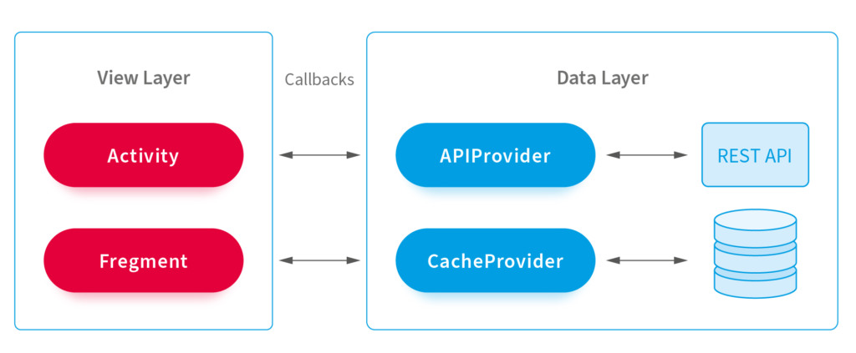

Figure 3 : Application Architecture

## Implementation Plan

|  |  |
| --- | --- |
|  | Include recommendations that lead to your proposed solution. Summarize what you’re proposing to do and how you’re going to meet the goals. You’ll be able to expand on the details within the ‘Our Proposal’ section. |

|  |  |
| --- | --- |
| Phase | Task Breakdown |
| ML Model | * Data sourcing * Data preprocessing * Feature engineering * Tunning * Model validation * Prediction |
| ArGIS | * Geo tracking (location, IP) * Device tracking (Device, OS, Platform) * Real-time monitoring * Map integration |
| App Development | * UI Design (Home, Dashboard, User Profile, Login, Register) * Authentication and Authorization * API development * Database design * Deployment (Cloud, Playstore) |

## Technology Use

|  |  |
| --- | --- |
|  | Include recommendations that lead to your proposed solution. Summarize what you’re proposing to do and how you’re going to meet the goals. You’ll be able to expand on the details within the ‘Our Proposal’ section. |

|  |  |
| --- | --- |
| Implementation | Technology |
| Machine Learning | * Programming language – Python * Integrated development environment (IDE) – Jupyter Notebook * Machine learning algorithm – KNN * Model Deployment – IBM cloud hosting |
| ArGIS | * Geo tracking (location, IP) * Device tracking (Device, OS, Platform) * Real-time monitoring * Map integration |
| App Development | * Programming language – C#, JavaScript * Integrated development environment (IDE) – Visual Studio * Framework - .NET 6 * Database – MS SQL Server * API development – Minimal API * Database ORM – Entity framework 6.0 * Authentication – JWT * Backend deployment – Azrue cloud hosting * Frontend deployment – Google Playstore |